Main Title
Author¹, Author²
¹Department of Applied Languages, Faculty of Informatics and Management, University of Hradec Kralove, Czech Republic {email address}
²Department of Informatics and Quantitative Methods, Faculty of Informatics and Management, University of Hradec Králové, Czech Republic {email address}
Received on 2 April 2016; revised on 6 May 2016; accepted on 21 June 2016; published on 15 January 2017
ABSTRACT
Brief and apt information about the content of the paper. It outlines the research problem, goals, used methods, results of a research or a project, general conclusions and recommendations. It serves to a reader for an accurate decision of reading the whole paper. The extent is set to 150 up to 300 words.
KEYWORDS
Commonly used terms expressing the content of the paper and the researched problem. According to the keywords the paper can be accurately classified and looked up in the particular field. The number of keywords is set to 4 up to 8. Use commas to separate individual keywords.

1 INTRODUCTION
This template introduces the basic guidelines for formatting your ICTE Journal paper. The following instructions need to be followed in order for a paper to be accepted for review.
2 Styles
Edit the text using the predefined styles in the HOME tab.
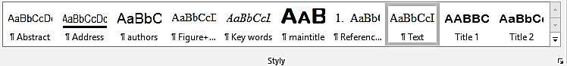
Figure 1 Styles
The template allows the use of two heading styles (Title 1 and Title 2). The Title 1 paragraph is numbered. The Text style is intended for writing paragraphs. Italics can be used to highlight parts of the text. The following bullet points can be used in a paragraph:
- Point 1
- Point 2
When order is important, a numerical list can be used:
- Point 1
- Point 2
Figures
Images and schemes should be aligned to the left. The caption should be placed under the figure (see the following example):
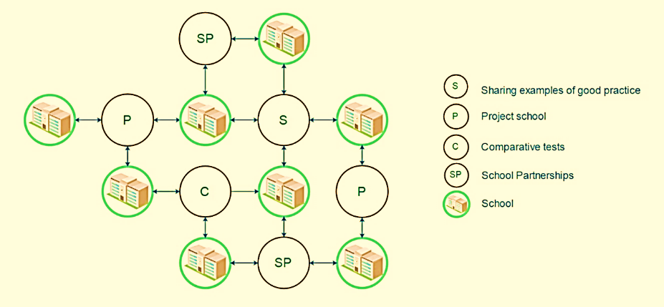
Figure 1 Network
Tables
Tables should be aligned to the left. Formatting of tables and captions can be seen in the following example:
Table 1 Students
Heading 1 | Heading 2 | Heading 3
Student 1 | 362 | 12
Student 2 | 14 | 34
Student 3 | 874 | 47
Conclusion
Text
Acknowledgements
Text
References
It is strictly required that the authors follow the APA standard regarding the structure and use of bibliographic quotations within their papers. Quotation generator is available at https://www.refme.com/citation-generator/apa/. References should be in alphabetical order.
Examples:
Charitonos, K., Blake, C., Scanlon, E., & Jones, A. (2012). Museum learning via social and mobile technologies: (How) can online interactions enhance the visitor experience?. British Journal Of Educational Technology, 43(5), 802-819. http://dx.doi.org/10.1111/j.1467-8535.2012.01360.x
Chatti, M. (2010). Personalization in technology enhanced learning (1st ed.). Aachen: Shaker.
Downes, S. (2010). Design Elements in a Personal Learning Environment. Slideshare.net. Retrieved 13 March 2017, from http://www.slideshare.net/Downes/design-elements-in-a-personal-learning-environment
Fiedler, S. & Pata, K. (2009). Distributed learning environments and social software. In Social software & developing community ontologies (pp. 145-158). Hershey: IGI Global.

